**How to import SQL file in mySQL Workbench?**

**Step1:**

Open Xamp and Mysql as you already did in lab. Create connection.

After opening MySql go to on files as showed in image.

File Open SQL Script…

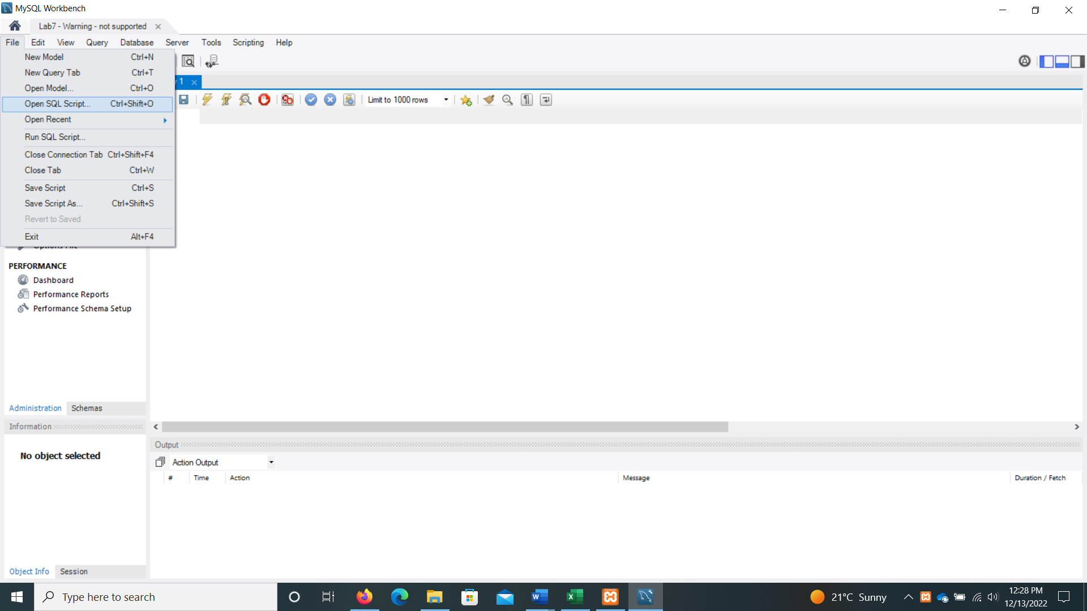

**Step2:**

After opening Open SQL Script Go to that path where you have downloaded your SQL file and select it. (Which I have shared on portal as RAR file)

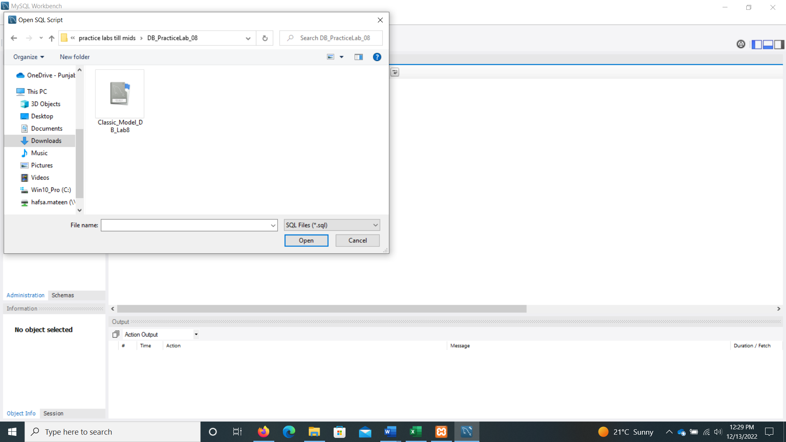

**Step3:**

After selecting the SQL file Open it. Your all data and SQL queries will be imported to your workbench as shown in the image below. And Run all the queries with the button as you can see in the image. 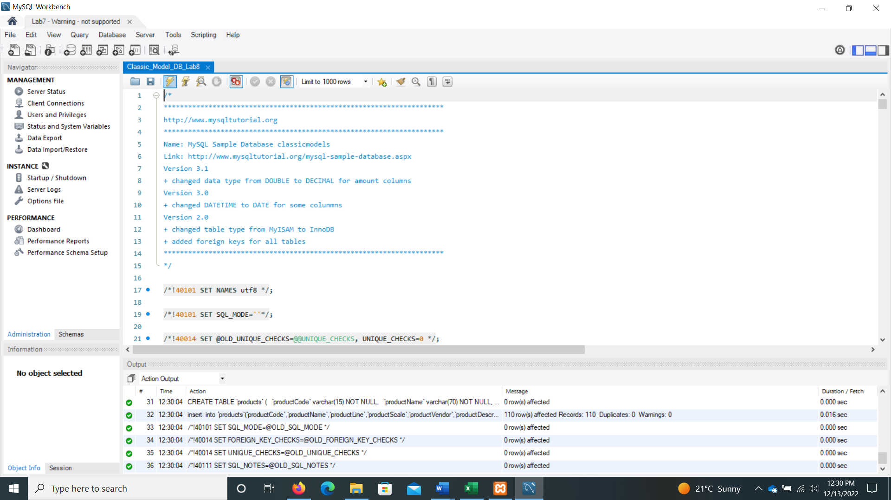

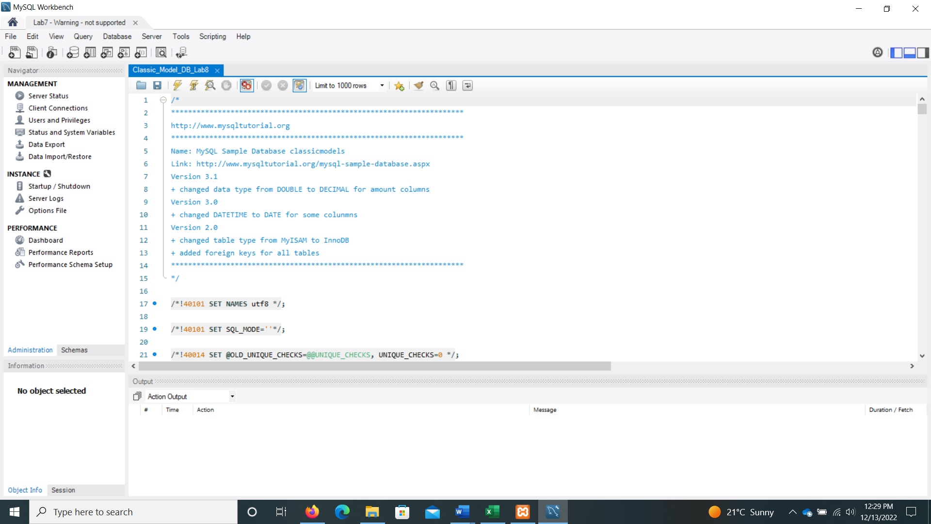

**Step4:**

After Run command all your table will be created along with data entries. Now you use this data for your task given in lab 7 and 8, and in exam as well.

